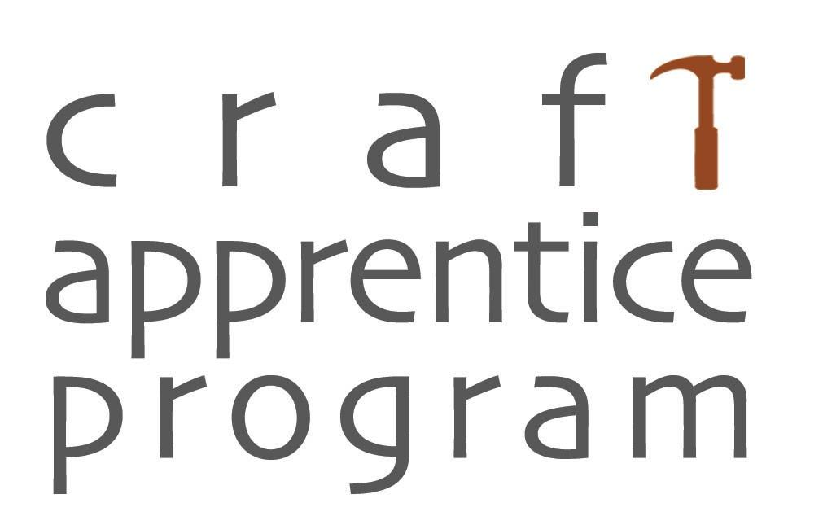
Craft Apprentice Program 2024:
Application checklist & questions

The applicant pair should have the following prepared to upload:
- -Mentor Work Images and descriptions (name file with artist last name and include artist name in the description text box)
- -Apprentice Work Images and descriptions (name file with artist last name and include artist name in the description text box)
- -Up to four additional support materials of your choice (optional)
  - Examples: Letter of Recommendation, Artist Statement, Biography, Extra images, Press, Resume, CV.

There are questions for the mentor, questions for the apprentice and questions for both mentor and apprentice. We recommend preparing an offline document for all your responses that you have both discussed, reviewed and agreed to. When that is complete one of you will create an account on the Maine Arts Commission grant site and cut/paste your responses into the form and upload your files. Only one account can access the application, however, you can share the login credentials, save your work and login repeatedly and separately. You may type directly into the application, however, in case of a tech-snafu, recommend you have a master copy to cut/paste from. All character maximums include spaces.

Overview Questions
-Which primary media will you be working in? (drop down menu)
-Please help the selection committee quickly understand how you will spend seven-months working together by describing the nature of the apprenticeship in one sentence. (Max: 100 characters)

Mentor Questions
- -Describe your studio practice including where you sell or exhibit your work. (Max: 500 characters)
- -To the best of your ability, assess the Apprentice’s potential and commitment. (Max: 500 characters)
- -How do you and the Apprentice know one another and why did you choose this apprentice? (Max: 500 characters)

Apprentice Questions
- -Tell us how long you have been working in this craft and any previous instruction. (Max: 500 characters)
- -Where are you currently making and how much time are you able to dedicate to it? (Max: 500 characters)
- -What do you hope to accomplish with this apprenticeship experience? (Max: 500 characters)
- -Why do you want to work with this Mentor in particular? (Max: 500 characters)
-How will you continue working with this craft in the future? (Max: 500 characters)
-Provide an itemized list of 1-10 items with their cost equaling $1,000*. (Max: 500 characters)

*Apprentice Budget: The Apprentice will receive $1,000 which must be spent during the seven-month apprenticeship to support the apprentice's goals and/or future studio practice. Items may include materials, equipment, books, tools, studio specific furnishings, etc. All purchased items become the property of the Apprentice. Funds may not be used for rent or ongoing existing overhead costs. Note: The Mentor Artist's funding is to compensate for their time and expertise, (do not submit a budget for these services).

For both Mentor & Apprentice:
- -​​Where will the teaching take place and what will your schedule look like? (Max: 500 characters)
- -Are there any distance, mobility, communication, technology, space, or schedule barriers of concern? How will you manage or how may we assist in helping with this? (Max: 300 characters)

Apprenticeship Plan Goals: MaineCAP requires one-on-one training from the Mentor Artist for 100 hours over seven months. List three goals that will advance the Apprentice's practice and career that can be taught in the 100 hours required. (500 characters EACH)*

- Goal 1: Please give a brief description of the goal and provide estimated hours to accomplish it.
- Goal 2: Please give a brief description of the goal and provide estimated hours to accomplish it.
- Goal 3: Please give a brief description of the goal and provide estimated hours to accomplish it.

Additional Information: Last field is optional and for any additional information you would like to share with the jurors to help them understand the nature of the apprenticeship. (Max: 1000 characters)

